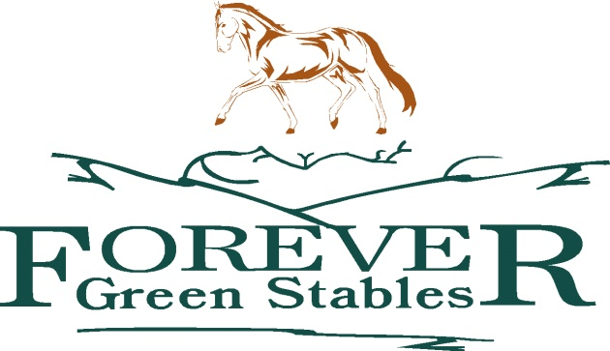
22455 Gore Road
Glen Robertson, Ontario
K0B 1H0
613-577-4702

AGREEMENT

BY SIGNING THIS DOCUMENT YOU WILL WAIVE CERTAIN LEGAL RIGHTS INCLUDING THE RIGHT TO SUE PLEASE READ CAREFULLY!
TO: Forever Green Stables and / or Lake of Two Mountains Hunt Club
(Referred to in this agreement as the "Provider")
AND TO: ALL PROPERTY OWNERS (PRIVATE, FEDERAL, PROVINCIAL, REGIONAL AND MUNICIPAL)
On my behalf, and on behalf of any minor children participating in these activities, for which I am legally responsible, I agree to the following:
ASSUMPTION OF RISKS
I am aware and understand that activities involving these horses involve many risks, dangers and hazards, including, but not limited to the following:
1. Horses, which are powerful and potentially dangerous animals, may change their behavior at any time and may, without warning, jump, run wildly, buck, kick, bite, or step on people or things;
2. Horses may collide with other horses or objects or trip, stumble or fall even if being led, ridden or driven, or attended to;
3. Negligence (which means, in general terms, a failure to exercise ordinary or proper care) of other riders or drivers my or my child's own failure to ride safely, within my or my child's ability or within designated areas and trails;
4. Equipment may fail;
5. Weather conditions can change and can sometimes be dangerous;
6. The nature of the terrain can change and has certain risks associated with it including, but not limited to, exposed natural objects, trees, streams and creeks;
7. The activities can sometimes be in remote areas and injuries or illness may occur and it may be a considerable distance to doctors, hospitals, or any other type of assistance; and
8. Negligence on the part of A PROPERTY OWNER AND/OR THE PROVIDER OR THEIR STAFF. I am also aware that the risks, dangers and hazards referred to above exist throughout the trail, stable, practice and other areas and many are unmarked. I understand and acknowledge that no amount of caution, experience or instruction can eliminate all of the risks involved and I freely accept and fully assume all such risks, dangers and hazards and the possibility of personal injury, death, property damage and damages or loss resulting there from.
INITIALS ______________
RELEASE OF LIABILITY, WAIVER OF CLAIMS AND INDEMNITY AGREEMENT
In consideration of the Provider providing me or my child with their horse or sleigh riding or carriage driving and other services and permitting my or my child's user of their equipment, and other facilities and the Property Owners providing me or my child with the use of their property (hereinafter collectively referred to as "the Services"), I hereby agree as follows:
1. TO WAIVE ANY AND ALL CLAIMS that I or my child have or may in the future have against a Property Owner or the Provider, and their directors, officers, employees, agents, representatives, and volunteers (all of whom are hereinafter collectively referred to as "THE RELEASEES") and TO RELEASE THE RELEASEES from any and all liability for any loss, damage, injury or expense that I or my child may suffer, or that my or my child's, next of kin may suffer as a result of my or my child's use of the services or due to any cause whatsoever. INCLUDING NEGLIGENCE, BREACH OF CONTRACT, OR BREACH OF ANY STATUTORY OR OTHER DUTY OF CARE INCLUDING ANY DUTY OF CARE OWNED UNDER THE "OCCUPIERS LIABILITY ACT" ON THE PART OF THE RELEASEES;
2. TO HOLD HARMLESS AND INDEMNIFY THE RELEASEES from any and all liability for any damage to the property of or personal injury to any third party resulting from my or my child's use of the services;
3. This Agreement shall be effective and binding upon my or my child's heirs, next of kin, executors, administrators, assigns and representatives in the event of my or my child's death or incapacity;
4. This agreement shall be governed by and interpreted in accordance with the laws of the province of Ontario; and
5. Any litigation involving the parties this Agreement shall be brought within the Province of Ontario.
INITIALS ______________
In entering into this Agreement, I am not relying upon any oral or written representations or statements made by the Releasee other that what is set forth in this Agreement.
I HAVE READ AND UNDERSTAND THIS AGREEMENT AND I AM AWARE THAT BY SIGNING THIS AGREEMENT, FROM THIS DAY FORWARD, I AM WAIVING CERTAIN LEGAL RIGHTS WHICH I, MY CHILD, MY HEIRS, NEXT OF KIN, EXECUTORS, ADMINISTRATORS, ASSIGNS AND/OR REPRESENTATIVES MAY HAVE AGAINST THE RELEASEES.
Signed this __________________________________ day of ____________________, 20 __________.
Name _________________________________
- Under Age Child: _______________________________ DOB _________________________
(under 19 years)
- Under Age Child: _______________________________ DOB _________________________
(under 19 years)
Under Age Child: _______________________________ DOB _________________________
(under 19 years)
THIS AGREEMENT MUST BE COMPLETED IN FULL, SIGNED, DATED, AND WITNESSED BEFORE ANY ACTIVITY WITH HORSES MAY BE UNDERTAKEN

Email address:________________________ Address:____________________________

Telephone Number: ______________________________________________

